**THE DOOR LOCK SECURITY**

**Description:**

The door lock security system is used to ensure security for rooms, houses, entrances, offices,.... Each lock security will have a different password and if you want to go throw, you must enter the correct password. If you enter the password more than 5 times, the system will alarm.

1. **FUNCTION REQUIREMENT**

|  |  |  |
| --- | --- | --- |
| LABEL | DETAIL | |
| FR1 |  | Display LCD |
|  | FR1.1 | Display “ENTER PASSWORD” |
|  | FR1.2 | If password is not correct, display “WRONG PASSWORD” |
|  | FR1.3 | Display “ENTER PASSWORD” after “WRONG PASSWORD” 100ms |
|  | PR1.4 | If password is correct, display “SUCCESSFUL ACCESS” |
|  | FR1.5 | Display two options when enter successfully:  “OPEN THE DOOR”  “CHANGE PASSWORD” |
|  | FR1.6 | Display “ * ” when entering one character |
| FR2 |  | Using keypad to enter password |
|  | FR2.1 | Enter password by pressing button on keypad |
|  | FR2.2 | Can enter password again if it is not over 3 times |
|  | FR2.3 | Pressing “ * “ to delete one character |
|  | FR2.4 | Password is 6 numbers |
|  | FR2.5 | Choose option by pressing “ * “ or “ # “ when entering correct password:  “ * “ : Open the door  “ # “: Changing password |
| FR3 |  | Warning by led |
|  | FR3.1 | LED turn on if enter incorrect password |
|  | FR3.2 | LED warning about 30 minutes |
|  | FR3.3 | LED turn on to warn outing of power |
|  | FR3.4 | Turn off by another contactor in house/room,… |
| FR4 |  | Warning by using buzzer |
|  | FR4.1 | Turn on buzzer if enter incorrect password |
|  | FR4.2 | Buzzer warning about 30 minutes |
|  | FR4.3 | Turn off by another contactor in house/room,… |
| FR5 |  | Control motor to unlock the door if enter correct password |
| FR6 |  | Using RFID card |
|  | FR6.1 | Can access by using RFID card, similar to enter password |
|  | FR6.2 | Using RFID card to turn off warning system |

1. **NON - FUNCTIONAL REQUIREMENT**

|  |  |  |
| --- | --- | --- |
| LABEL | DETAIL | |
| NFR1 |  | LCD 16x2 |
| NFR2 |  | Sound intensity about 60dB – 110dB |
| NFR3 |  | Battery life about 12 months |
| NFR4 |  | Using backup power to replace when main power runs out |
| NFR5 |  | Using adaptor to supply power when main power runs out |
| NFR6 |  | Size of device about 30cm x 15cm |

1. **FUNCTION**

|  |  |  |
| --- | --- | --- |
| Component | Classify | Function |
| Atmel Studio 7 | Software | Write sketches, upload on chip for execution |
| Atmega32 | Hardware | Main microcontroller reads inputs like a finger on a button and turn it into an output: activating motor and buzzer, pushing something to LCD |
| LCD display | Hardware/User Interface | Display information |
| Matrix Keypad | Hardware/User Interface | Take input from the user |
| Servo Motor | Hardware | Produce torque and velocity based on supplied current and voltage |
| Battery | Hardware | Power supply |
| Buzzer | Hardware | Sound emitter |

1. 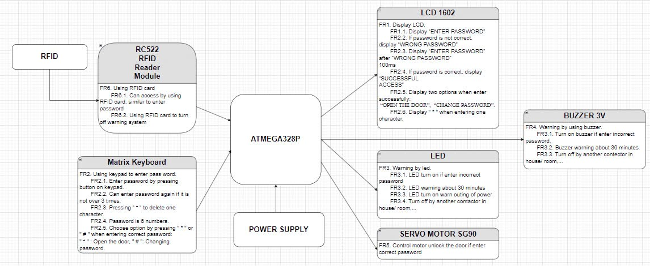**BLOCK DIAGRAM**
2. **TEST CASE**

|  |  |  |  |
| --- | --- | --- | --- |
| **Features** | **Ojective** | **Test Step** | **Result** |
| Create Password | Enter new password with 6 numbers from keypad | Enter enough 6 numbers | The screen switch to Verify new password. |
| Enter not enough 6 numbers | Waiting until user enter enough 6 numbers. |
| Verify new password | Verify the password after password has been entered. | Verify successfully (password matches) | Password has been set. |
| Verify unsuccessfully (password does not match) | Password has not been set. Requiring enter password again. |
| Enter password | Password should not show clear number while inputting the password. | Enter password from keypad | Display “*” while entering the number from keypad. |
| Enter password from keypad | Verify correct password | Display “Successful access”, turn on server motor and unlock. |
| Verify wrong password | Display “Unsuccessful access”, require enter password again. Keep door locking. |
| Verify wrong password | Not enable more than attempts for unsuccessful attempts while log-in and track with timestamps and logs. | Verify wrong password over 3 times | Buzzer will be activated. |
| Verify wrong password over 5 times | Display “Try again after 1 minute” and block the screen in 1 minute. Keep door locking. |
| Change password | Should have provision to change the password by end users and by back end when end user forgotten the password. | Verify the last password or ID admin user | Allow user create new password. |

|  |  |  |
| --- | --- | --- |
| LINH KIỆN | GIAO TIẾP | GIÁ THÀNH |
| Matrix Keyboard 4x4 | 8 GPIO | 12.000 VNĐ |
| LCD 1602 | I2C | 40.000 VNĐ |
| Buzzer 3V | 1 GPIO | 6.000 VNĐ |
| Động cơ servo SG90 | PWM | 34.000 VNĐ |
| Nguồn Adapter |  | 70.000 VNĐ |
| Jack DC | VCC & GND pins | 5.000 VNĐ |
| Module RFID | 5 GPIO | 140.000 VNĐ |
| Led báo hiệu | 1 GPIO | 4.000 VNĐ/10 con |
| Atmega328P |  | 50.000 VNĐ |
| Tổng |  | 261.000 VNĐ |